Virgilio Cerutti
Curriculum Vitae & Profile

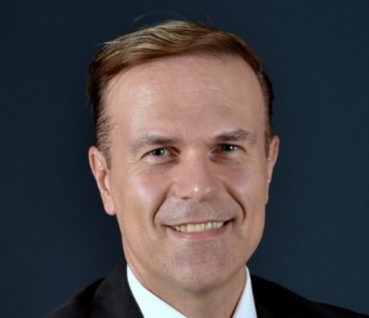

Virgilio Cerutti is Head of Business Development Global Coordination at Stellantis and as of July ’23 he serves as CEO of Teksid SpA as well. He has cooperated with Politecnico di Torino since 2019, teaching “Business Development and Corporate Finance” and “Strategic Marketing and Products Planning”.
Prior to the current role Virgilio was Head of Business Development Central Coordination at FCA Group (Fiat Chrysler Automobiles) since February 2013, supporting the Group’s Top Management regarding key topics as Strategy, Business Development and M&A.
Virgilio’s past roles within FCA Group have included Global Head of Business Development for Magneti Marelli Group where, moreover, he served as CEO and General Manager at several Magneti Marelli’s Business Lines (Powertrain & Electronics, Suspension, Shock Absorbers, Plastic Components & Modules) and Regions (Latin America) based in Milan, Turin and Sao Paulo. During his tenure as CEO for Latin America he led the team who launched and developed the Software Flex Fuel Technology, which shaped the Brasilian automotive energy matrix that still is unique in the world from the sustainability standpoint; sustainability standpoint that represents a core perspective of the courses teached at Politecnico.
He joined Fiat Group in 1998 where he held several positions as Deputy Head Fiat Group Purchasing, Fiat Group Global Head of Purchasing for Powertrain and Electronics, Vice President Corporate Initiatives, Global Six Sigma Program Manager and HR Manager.
Before joining Fiat Group, he worked at Lear Corporation, Officine Giordano and Trade Component Systems.
Virgilio holds a High School Diploma in Electronic Engineering from the Engineering School C. Olivetti of Ivrea, a Degree in Political Science from the University of Turin and later studied at the Bologna Business School where he received a Master of Business Administration with a major in Corporate Finance. He attended various specialization courses at Insead, Wilmington Plc, Amana Key, Isvor.

